# CS 255 System Design Document Template

## UML Diagrams

### UML Use Case Diagram

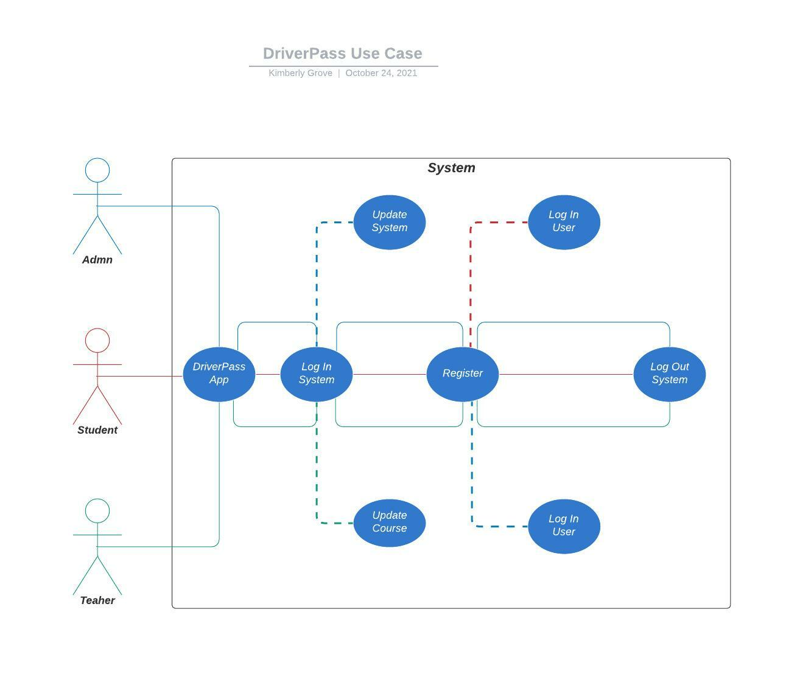

### UML Activity Diagrams

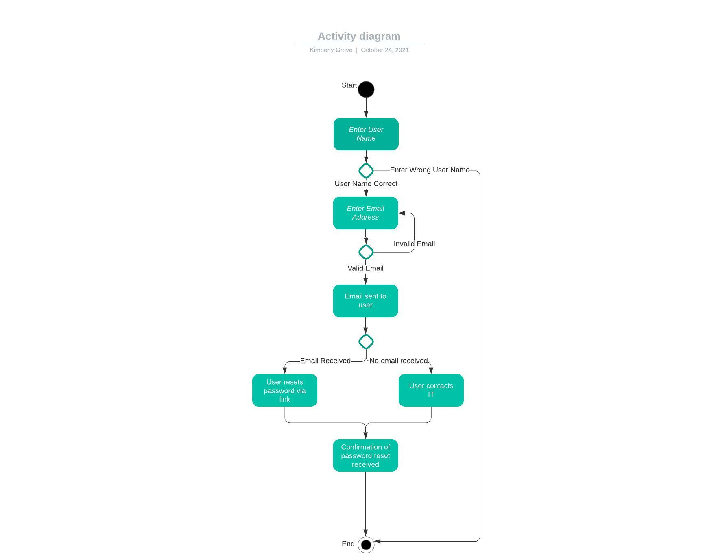

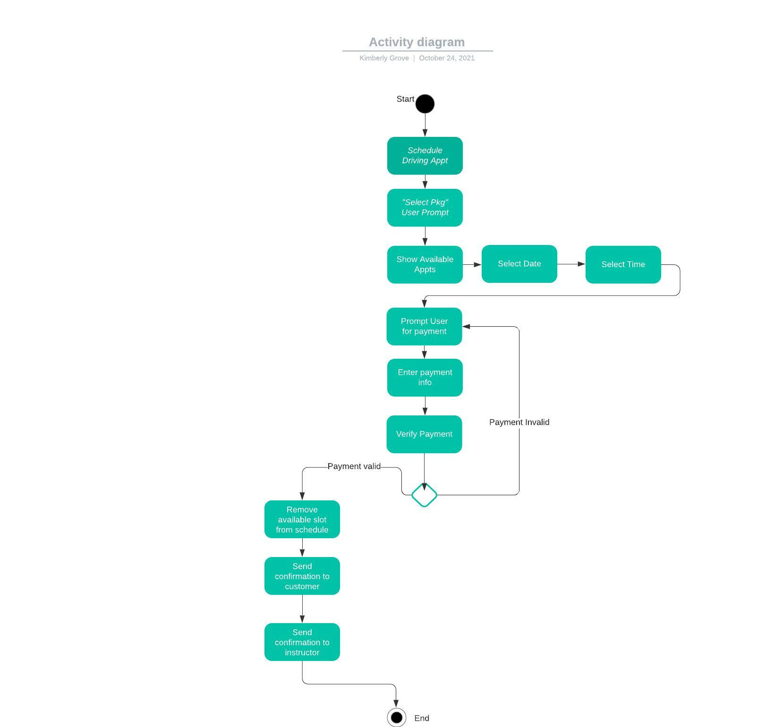

### UML Sequence Diagram

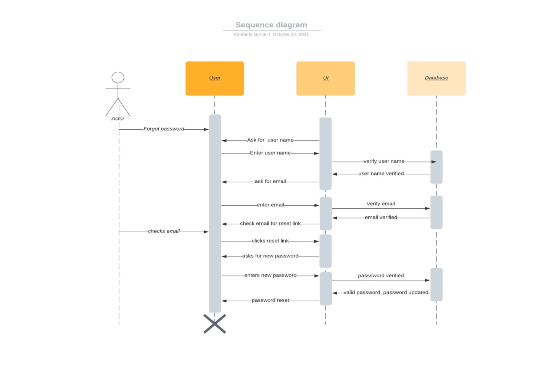

### UML Class Diagram

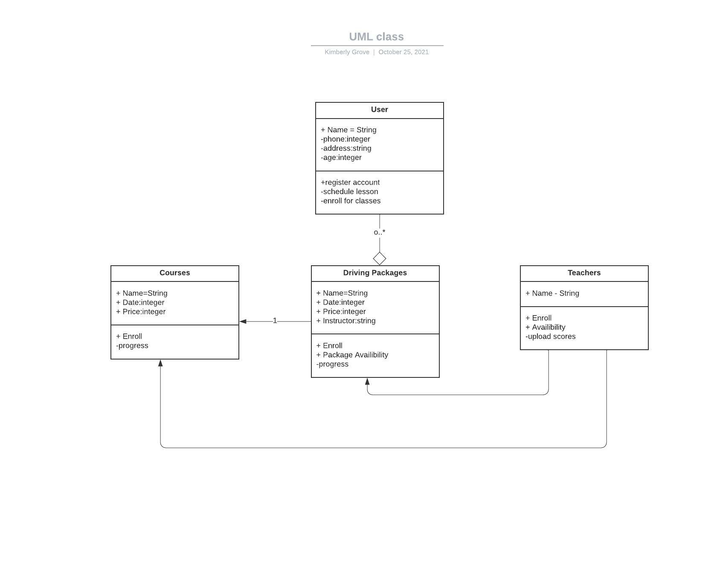

## Technical Requirements

*Technical requirements needed:*

* *Cloud server with adequate space for system to run smoothly*
* *Web based system for updating and revising program as necessary*
* *Scheduling tool such as Google calendar*
* *Diagram tool such as Lucidchart*
* *IT personnel to keep system up to date and to handle any problems that arise*